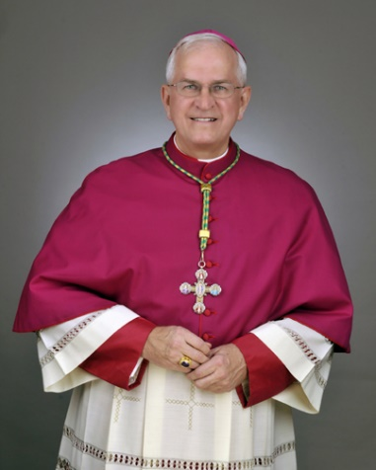
Directions for the Letter to the Bishop
Due Jan. 15, 2021

Checklist:
- My letter is thoughtfully written
- My letter is typed
- I formatted my letter like the example (see reverse)
- I typed my name and signed my name

You want your letter to be thoughtful and substantial enough to express your understanding and desire for the Sacrament of Confirmation. With that in mind…this is an example of a BAD confirmation letter. What’s wrong with it?
[See reverse for a tips on a well written letter]

Hello, Archbishop Kurtz:

Through my preparation for Confirmation I have learned a lot. Confirmation means a lot to me. In confirmation class I really liked it when we learned about Jesus and the Holy Spirit and other interesting things. The service project I did when I worked in the nursery at church was really cool and helped me to love people more.
Bad Example

My patron saint is St. Isadore and I picked him because he was holy and loved God. I think he will help me to love God more.

I think that confirmation is going to change my life because it will make me stronger in my faith. And I want to say for myself that I am Catholic.

I am looking forward to receiving the gift of fortitude because it will make me more brave and I need to be more brave.

Sincerely,
Billy the Kid
Billy the Kid

Why is this a bad example?

- It does not show deep thought and real desire.
- It does not demonstrate an understanding of the sacrament.
- It does not relate anything about your personal preparation for confirmation (it is generic).
- It fails to follow proper letter format.
- It seems like it was copied off a handout. 😊

Billy Smith
1234 Spirit Street
Elizabethtown, KY 42701

January 19, 2020

The Most Reverend Joseph E. Kurtz, D.D.
Archbishop of the Diocese of Louisville, KY
3940 Poplar Level Rd
Louisville, KY 40213

Dear Archbishop Kurtz,

Introduce self and state you wish to be confirmed at St. James (you don’t need to copy this exactly!….) My name is Billy and I am a sophomore and member of St. James parish in Elizabethtown. For the past year and a half, I have been working towards preparation for Confirmation this February. It is my desire to be confirmed at Saint James Church on February 23, 2020.

Tell the reasons you want to be confirmed – What does confirmation mean to you? What will it do for you?

Which Saint did you choose? Why? Did they do something inspiring? Do they have a virtue you wish to imitate? Don’t say “I like this name.”

Discuss your service projects and how they have helped you grow in your faith.

Respectfully yours,

Signature

Your typed name

Some topics to discuss:
- What we are learning in Confirmation Class
- The role of your Patron Saint in your life
- Which fruits of confirmation do you look forward to receiving and how will they change your life? (Look at paragraph 1303 in the Catechism for a list of the effects!)
- Which gift of the Holy Spirit do you most desire and believe to be particularly important in your life? (see handout for a review!)
- Reflect on your service project(s) and how they helped you grow
- Who you picked as a sponsor and how they witness to the Catholic life for you

Some of the commitments listed for confirmandi (in other words things that you will do as a confirmed Catholic – it might be good to talk about these things)
- pray for growth in faith, hope, and love
- strive for greater maturity in my faith
- accept more responsibility in my faith, my church, my community

Note: DO NOT JUST USE THESE AS SENTENCE STARTERS….
SEE THE REVERSE FOR AN EXAMPLE OF WHAT NOT TO DO 😊

