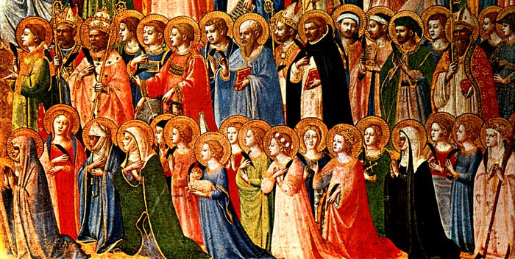
All You Holy Saints of God, Pray for us!

Throughout Salvation History God has given A new name
to those whom he gives a new mission.

At Confirmation we “Let a Saint Choose Us”
and receive their Name as our new name.

- Pray… “Who in Heaven wants to walk with me?”
- Listen... This includes listening to your heart as you read through some Saint Stories. You can find some helpful resources here:
- https://lifeteen.com/blog/find-your-saint/
- https://lifeteen.com/blog/biggest-best-list-confirmation-saints-guys-girls/
- https://info.franciscanmedia.org/saints
- https://www.catholic.org/saints/popular.php
- Pick Three… Identify your top 3 choices: Investigate, ask, pray!
- Commit… Ask the Saint to become your patron as you accept their name from the bishop.
- Saint Snapshot… see reverse for directions!

“Top 3” Due November 1 (All Saints Day!)
Saint Snapshot due November 22
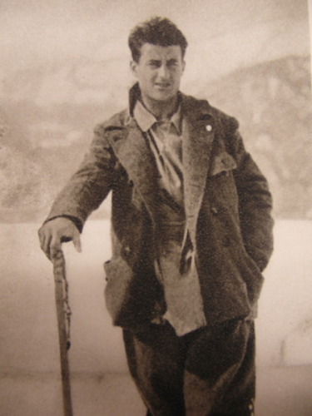
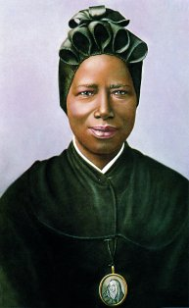

Saint
Snapshot

Write up a “snapshot” of your patron saint! How is he/she a model of virtue? Explain why you want their prayers!

- No need to include the “less than interesting” facts… (I can look on Wikipedia for those…)
- Do write in 1st person:
  - I first encountered Saint ____ when…
  - I was drawn to him/her because…
  - This is my favorite story about his/her life….
  - I want to imitate his/her virtue of ______. An example of this virtue in his/her life is when…
  - This virtue is important in my life because…
- Your Snapshot should be at least 2 pages, typed, double-spaced, 1” margins, 12 pt. font!

