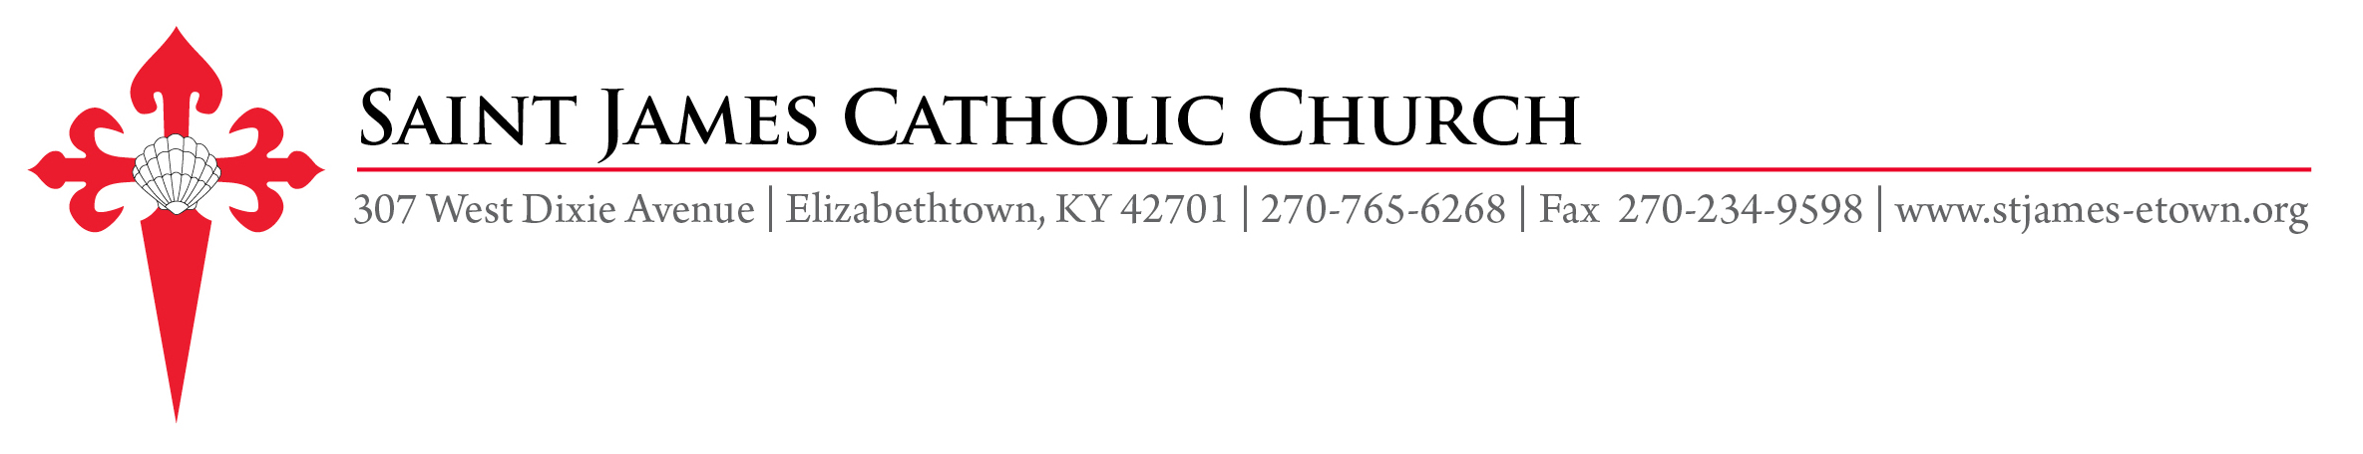
CONFIRMATION SPONSOR INFORMATION

I have agreed to serve as sponsor for _____________________________________________ in the preparation
(Name of Candidate)
process for the Sacrament of Confirmation.

I certify that I am a fully initiated member of the Catholic Church. I am baptized, confirmed, participate in
Sunday Mass and in the life of my parish community. If married, I am married according to the sanctions of the
Catholic Church. I am a member of _______________________ parish in _____________________________.
(Name of Parish) (City, State)
Pastor’s Acknowledgement:
_______ As Pastor, I verify that the above named person(s) is/are active Catholics in my parish and in good standing.
_______ As Pastor, I am unable to verify that the above-named person(s) is/are active Catholics in my parish. Comment(s):_______________________________________________________________________________

PASTOR SIGNATURE __________________________________ DATE ________________

I will be present to this candidate throughout the preparation and have agreed to the Confirmation Expectations
Covenant. I will be present for the rehearsal and “rehearsal dinner” on Saturday, February 6 and the Confirmation Mass on Sunday, February 7 at noon.

CONFIRMATION COVENANT - EXPECTATION OF THE CANDIDATE’S SPONSOR
- The sponsor promises to support the candidate through prayer in this preparatory time before confirmation.
- The sponsor promises to provide support and guidance to the candidate by remaining in contact with the candidate throughout the Confirmation process.
- The sponsor promises to make every effort to attend both the confirmation rehearsal/dinner and mass.

SPONSOR’S NAME ____________________________________________
(Please Print Plainly)
RELATIONSHIP TO CANDIDATE ________________________________

PHONE ______________________________ EMAIL ADDRESS __________________________________

SPONSOR’S SIGNATURE ____________________________________ DATE _______________________

Please submit this form via mail (see address above) or email by November 22, 2020
to Fabiola Sanchez * fsanchez@stjames-etown.org

